**PART 1:**

1.

2.

3.

4.



5.

6.



7.

8.

9.

**PART 2:**

2.

a. 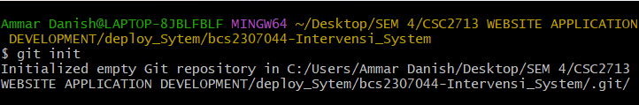

b.

c.

d.

3.